Waabanong Weekly Update
Delivered July 6, 2026
Week of June 29 to July 3, 2026
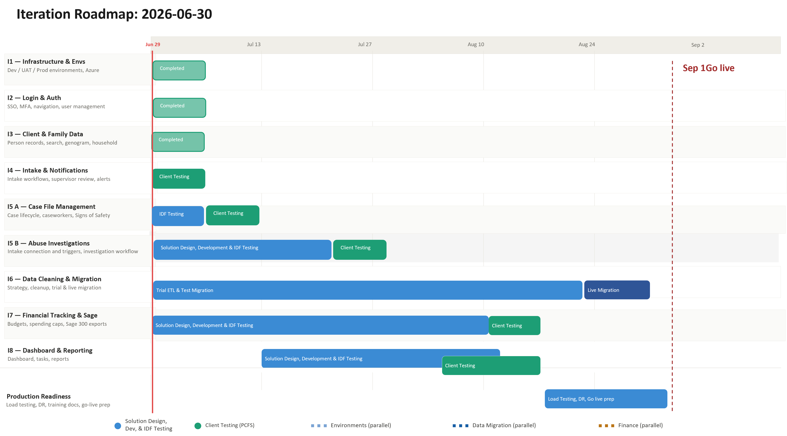

Iteration | Status | Current phase | Notes
I1 - System Infrastructure & Environments | In progress | PCFS Testing | Version bumps only
I2 - Login & Authorization | In progress | PCFS Testing | No changes this week
I3 - Client, Member & Family Data | In progress | PCFS Testing | Person/relationship search fixes; Kinship connection fix
I4 - Intake Management & Automated Notifications | In progress | PCFS Testing | Intake reopen workflow added; supervisor review and referral eligibility refinements
I5 A - Case File Management & Signs of Safety | In progress | Development | Automated F2F progress; legal status, placement, and case note fixes; No Contact Order badge added
I5 B – Abuse Investigations | In Progress | Solution design | No activity this week
I6 - Data Migration | In progress | Planning | FAMCare schema export coordination underway; live (scrubbed) data access requested
I7 - Financial Tracking & Exports for Sage | In progress | Solution design | No activity this week
I8 - My Dashboard & Reporting | Not started

Project Management & General
Weekly Progress
- No client meetings this week — a heavy development week with roughly 40 commits across Jun 29–Jul 3, concentrated in Intake Management and Case File / Signs of Safety.
- FAMCare data migration coordination continued by email — see I6 for details.
- Ross requested a session to review Intake Module workflow changes/additional triggers (following up on a meeting with Darryl); to be scheduled.
- Minor housekeeping: search card UI fix and an internal seeder typo correction.
I1 - System Infrastructure & Environments
Features
- Set up Development, Testing, and Production environments
Weekly Progress
- Footer version bump (twice this week, Jun 29 and Jul 3); no functional infrastructure changes.
I2 - Login & Authorization
Features
- Microsoft 365–based authentication
- User login
Weekly Progress
- No authentication changes this week.
I3 - Client, Member & Family Data
Features
- Centralized person records (children, adults, limited profiles)
  - Duplicate prevention
- Family and household structures
  - Multi-generation relationships
- Reciprocal relationship logic
- Global search across people and families
Weekly Progress
- Person search: workers are now required to specify relationship type when searching for a person to link (two related fixes).
- Fixed: a Kinship connection was not being created correctly.
- General relationship-data updates.
I4 - Intake Management & Automated Notifications
Features
- Structured intake workflows with mandatory fields
- Intake status tracking and lifecycle
- Supervisor review and approval processes
- Ability to resolve intake without opening a case
- Escalation from intake to case creation
- Printable intake records
- Automated notifications:
  - In-application alerts
  - Defined external channels (email/messaging)
Weekly Progress
- Significant intake work this week:
- **Intake reopen workflow added** — new routes, admin modals, review banners, and task migration to support reopening a closed intake
- Workers can now add multiple people to an intake directly from the genogram
- Added the option to reassign an intake to a different worker
- Supervisor Review: JavaScript cleanup, new "Additional Info" checkbox, simplified task layout, and removal of an unused task-saving route
- Supervisor Review permissions extended to include the Admin role
- Prior contact check logic updated (two rounds of fixes)
- Updated Non-Family Connection role labels in intake referral eligibility
- Intake fields remain editable after case closure when an Admin is making the edit
- Updated validation rules for issue subcategory IDs on intake referral requests
- Fixed a modal overflow issue during intake reassignment that was hiding the focus ring
- Added "pending closure" as an advanced search filter option
- Worked on intake issue categories and response-time handling.
- Ross Gillingham requested a follow-up session to review Intake Module workflow changes and additional triggers, after meeting with Darryl on his first day back (Jun 29); session to be scheduled.
I5 A - Case File Management & Signs of Safety
Features
- Case file creation and lifecycle management
- Assignment of caseworkers and supervisors
- Case reassignment with approval
- Signs of Safety–aligned workflows, including:
  - Placement
  - Structured assessments
  - Safety goals and planning
  - Ongoing review checkpoints
- Visibility into historical and related cases
- Case notes for visits, services, and interactions
- Communication tracking across intake and case contexts
  - Document management: Person, Intake & Case
Weekly Progress
- Continued work on the automated Face-to-Face (F2F) visit workflow.
- Legal status module fixes:
- General bug fixes across the legal status modal
- Edit mode now correctly pre-selects the existing legal status type
- Fixed: replacing a document in the legal status modal was not replacing the prior version
- Legal status and placements now included in the case log
- Placements tab: legal status now correctly links to the existing document rather than prompting an upload
- Placement improvements:
- Close date validation added to the new placement modal
- Additional fields added for placement type
- Case file placement address fields now match the Person Profile address fields
- Placement Resource Homes now appear correctly in current households
- Case notes:
- Case note logs now capture when a person is added to or removed from a case
- Fixed a special-characters issue in case notes
- Genogram: workers can now multi-add people from the genogram directly onto case files
- Added a No Contact Order (NCO) badge, shown on genogram and caregiver modals
- Log tab: updated visit-log modal; added logging for checklist completion
- Added an "All" option to Stage 3 of the Existing Case File modal
I5 B – Abuse Investigations
Features
- Triggers and integration with Intake module
- Investigation workflow
- Investigation document management

Weekly Progress
- No new developments this week; solution design continues.
I6 - Data Cleaning and Migration
Features
- Develop a data migration strategy from FAMCare into Waabanong
- Support PCFS as they perform data cleanup
- Execute trial data migrations in a sandbox environment
- Perform live data migration
Weekly Progress
- FAMCare schema access and export coordination underway with PCFS and their IT vendor (Campfire):
- IDFusion (Varun) granted access to a SQL Dev environment and the FAMCare test database (Jun 29–30)
- Initial schema export received (Jun 30) but was not schema-only as expected; Varun identified the correct export method (SQL Server Management Studio → Generate Scripts → script entire database, with Indexes and Foreign Keys enabled, "Schema only" data option) and requested a corrected export
- Database assessed as complex — roughly 200 tables with inconsistent naming and structure; Ross and Varun began manually mapping tables; PCFS also identified additional data they want carried into the new system that isn't in the current export
- PCFS's team is meeting internally this week to confirm exactly what needs to be exported
- Access to live (scrubbed) production data has been requested, needed to confirm what data PCFS actually uses in practice before migration scripts are finalized — targeted within two weeks
I7 - Financial Tracking & Exports for Sage
Features (Potential scope may include)
- Intake-level emergency supports
- Case-level budgets
- Spending caps and approvals
- Export files to import into Sage 300
Weekly Progress
- No new activity this week; finance module remains in solution design pending Rob's documentation review and a follow-up session.
I8 - My Dashboard & Reporting
Features (Potential scope may include)
- My Dashboard (simple, quick reference to key items)
- Tasks & alerts
- Reporting (if required and not covered in other iterations)
Weekly Progress
- Future iteration per schedule (no dashboard/reporting work this week).

